**JAVA CODING CHALLENGE**

**HOSPITAL MANAGEMENT SYSTEM**

**J502 ABHISHEK A G**

**SQL QUERIES**

**DATABASE CREATION QUERY:**

create database HospitalDB;

use HospitalDB;

**TABLE CREATION QUERIES:**

create table Patients(

patientID int primary key auto_increment,

firstName varchar(50) not null,

lastName varchar(50) not null,

dateOfBirth date not null,

gender varchar(10),

contactNumber varchar(15),

address varchar(200)

);

create table doctors (

doctorid int primary key auto_increment,

firstname varchar(50) not null,

lastname varchar(50) not null,

specialization varchar(100),

contactnumber varchar(15)

);

create table appointments (

appointmentid int primary key auto_increment,

patientid int,

doctorid int,

appointmentdate date,

description varchar(255),

foreign key (patientid) references patients(patientid),

foreign key (doctorid) references doctors(doctorid)

);

**SAMPLE INSERTION QUERIES:**

INSERT INTO Doctors (firstName, lastName, specialization, contactNumber)

VALUES ('Ram', 'Kumar', 'Cardiology', '9988772211'),

('Sham', 'Kumar', 'Neurology', '8765432109');

insert into patients (firstname, lastname, dateofbirth, gender, contactnumber, address)

values

('Abhishek', 'Krishna', '1995-07-10', 'male', '9998887776', 'chennai'),

('Thea', 'marley', '1980-12-25', 'female', '8887776665', 'bangalore');

insert into appointments (patientid, doctorid, appointmentdate, description)

values

(1, 1, '2025-04-15', 'routine checkup'),

(2, 2, '2025-04-16', 'migraine treatment');

**TABLES:**

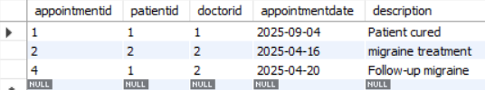

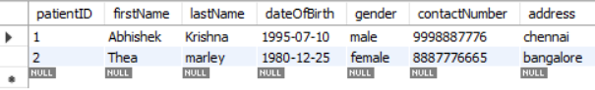

ss